**Watershed :**

→ The **watershed** is a classical algorithm used for segmentation, that is, for separating different objects in an **image**. Starting from user-defined markers, the **watershed** algorithm treats pixels values as a local topography (elevation).

Step : 1 ( Load the image )

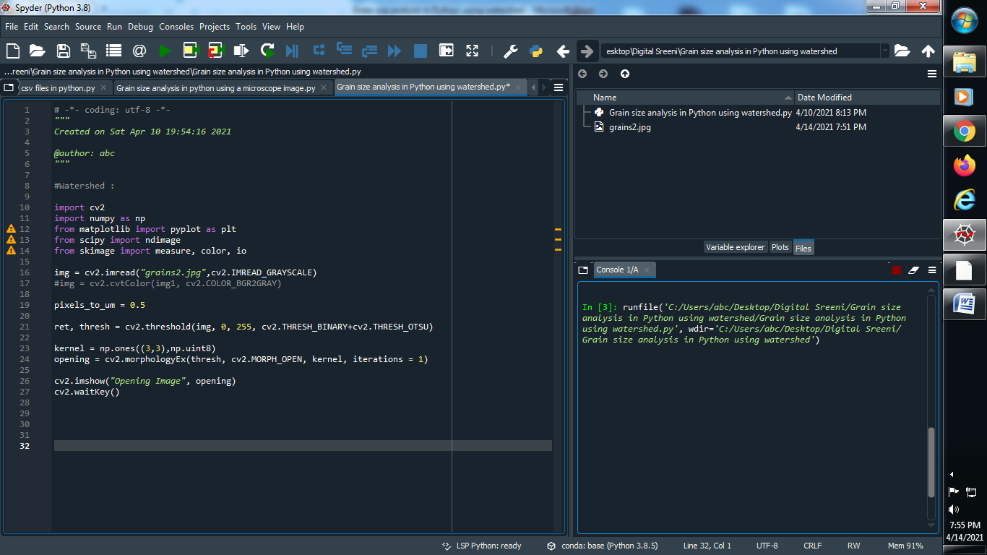

Output :

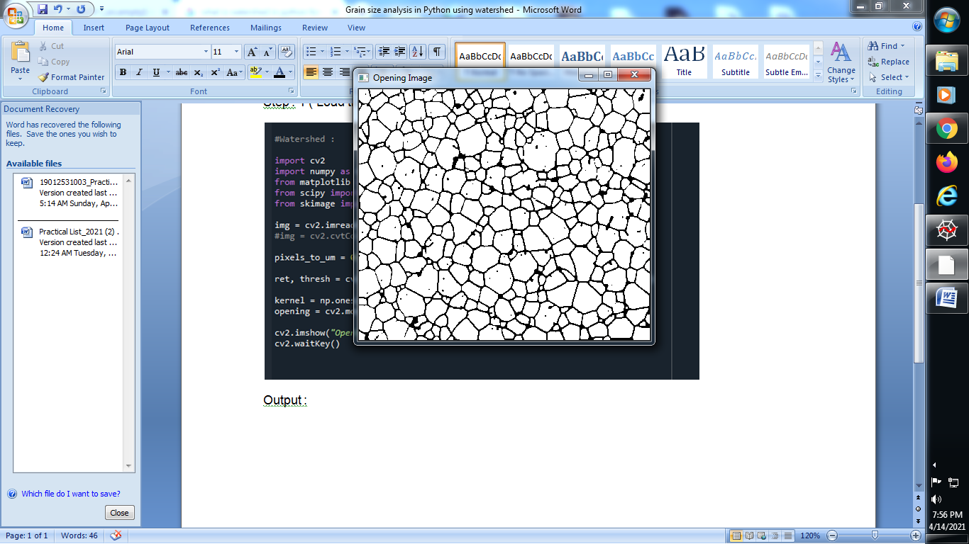

**Step : 2 ( Open background of image )**

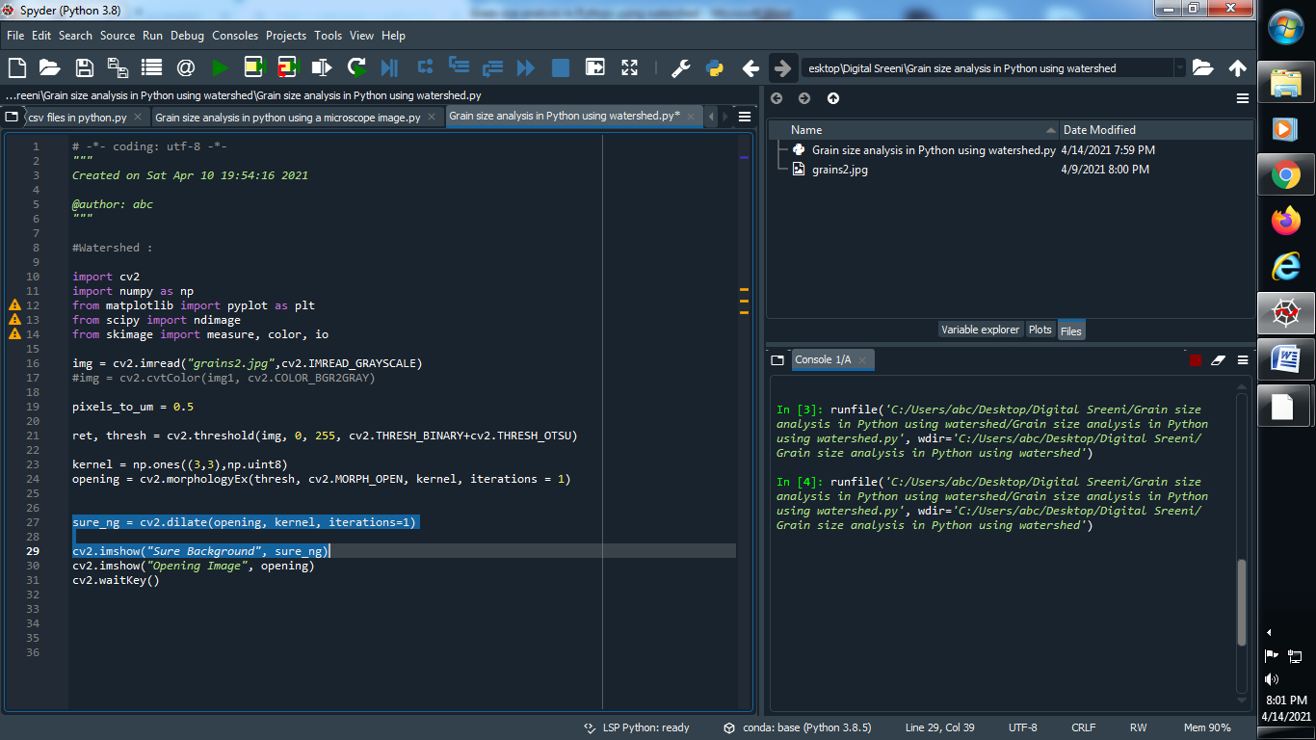

**Output :**

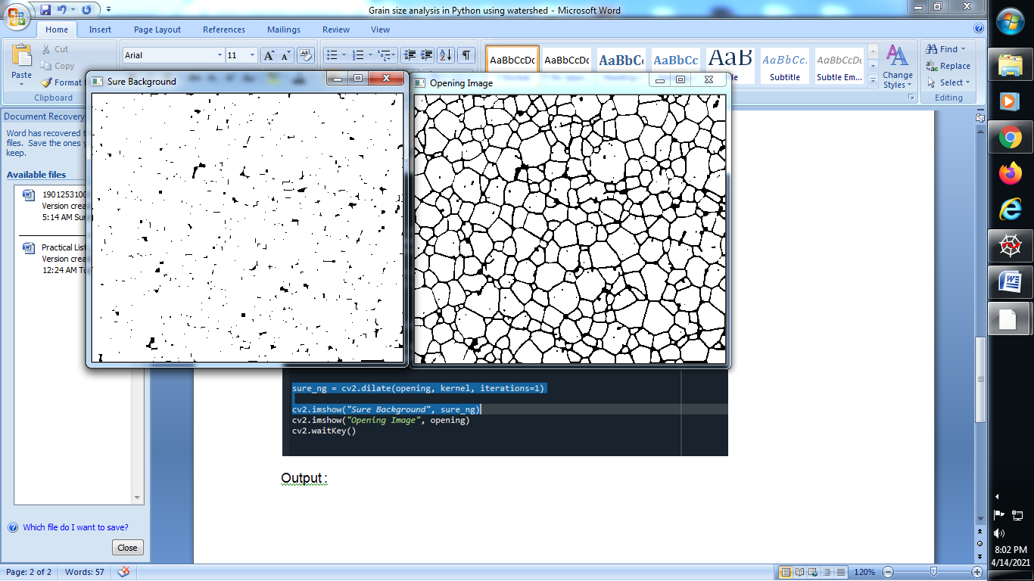

**Distance Transformation :**

→ A distance transformation converts a binary digital image, consisting of feature and non-feature pixels, into an image where all non-feature pixels have a value corresponding to the distance to the nearest feature pixel. Computing these distances is in principle a global operation.

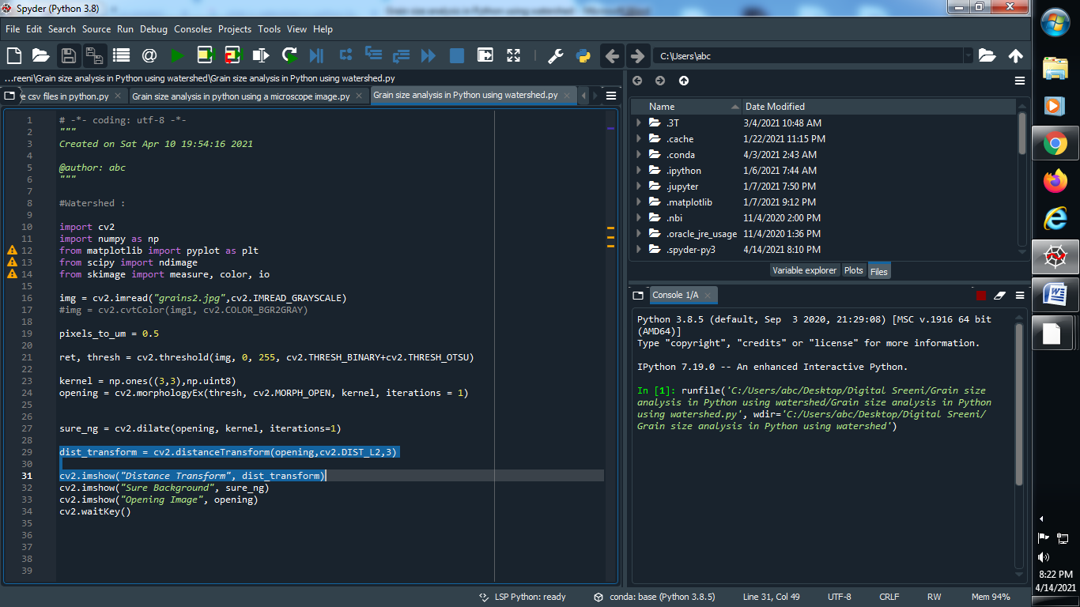

**Output :**

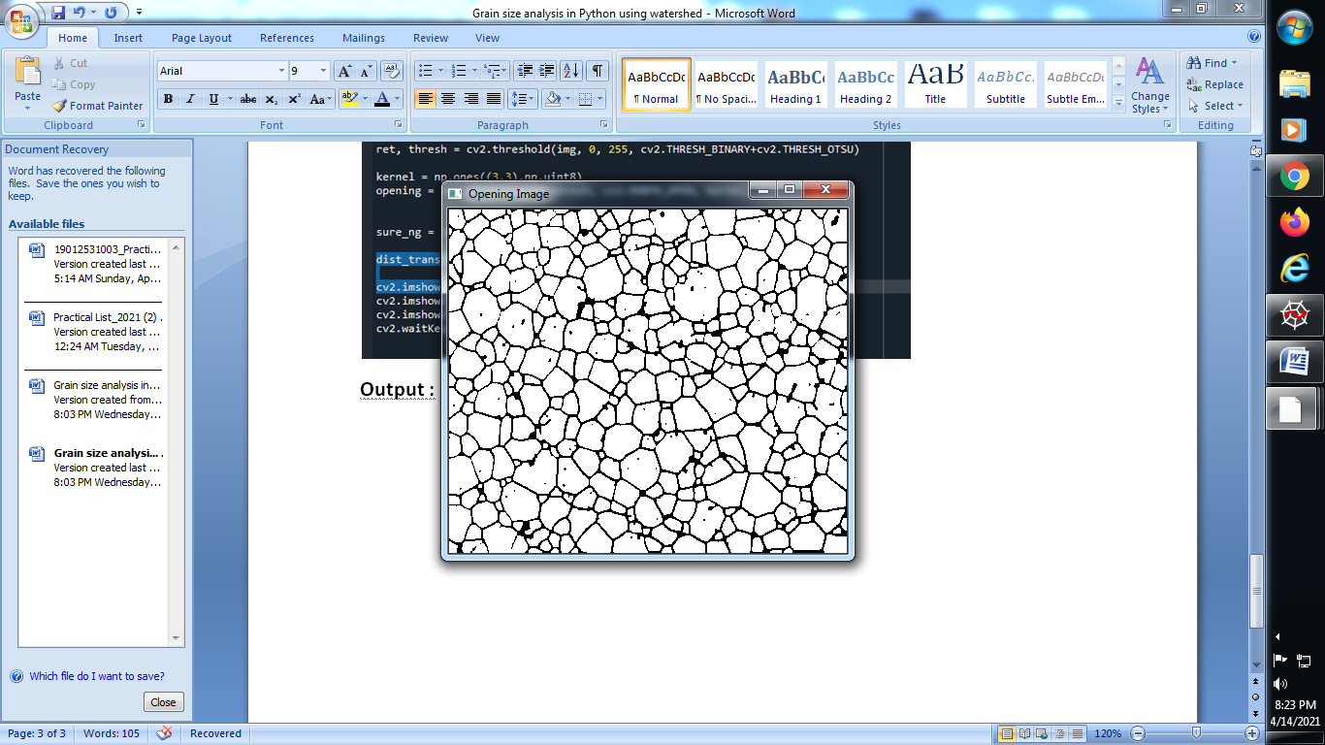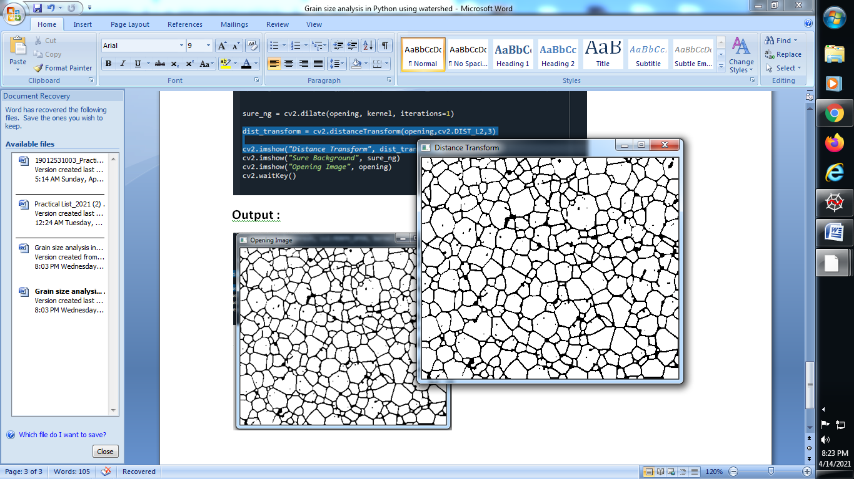

**Convert image into threshould image using distance transform :**

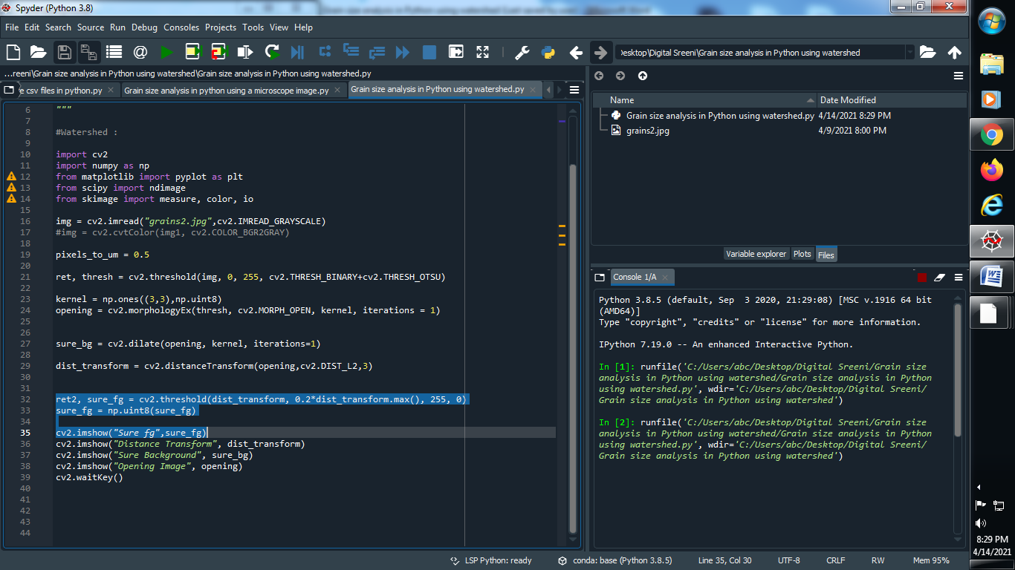

**Output :**

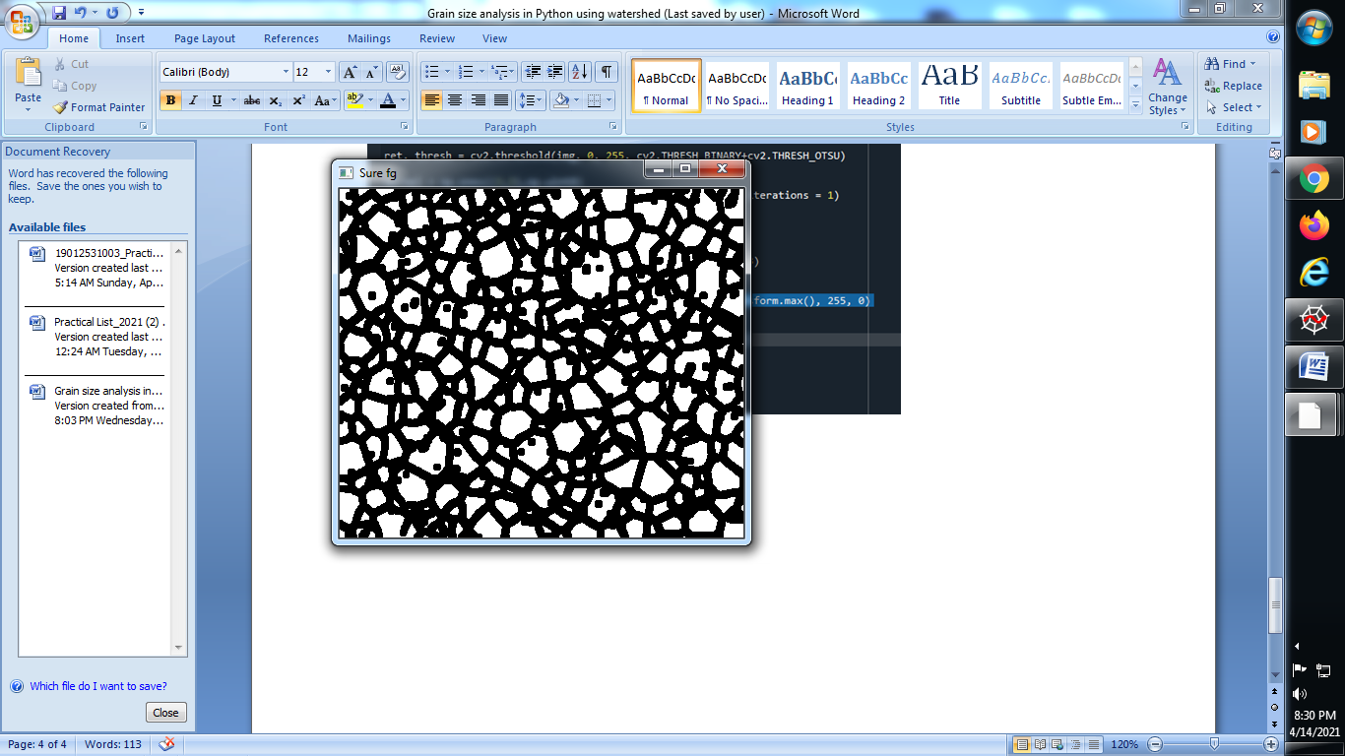

**→ Subtract the image :**

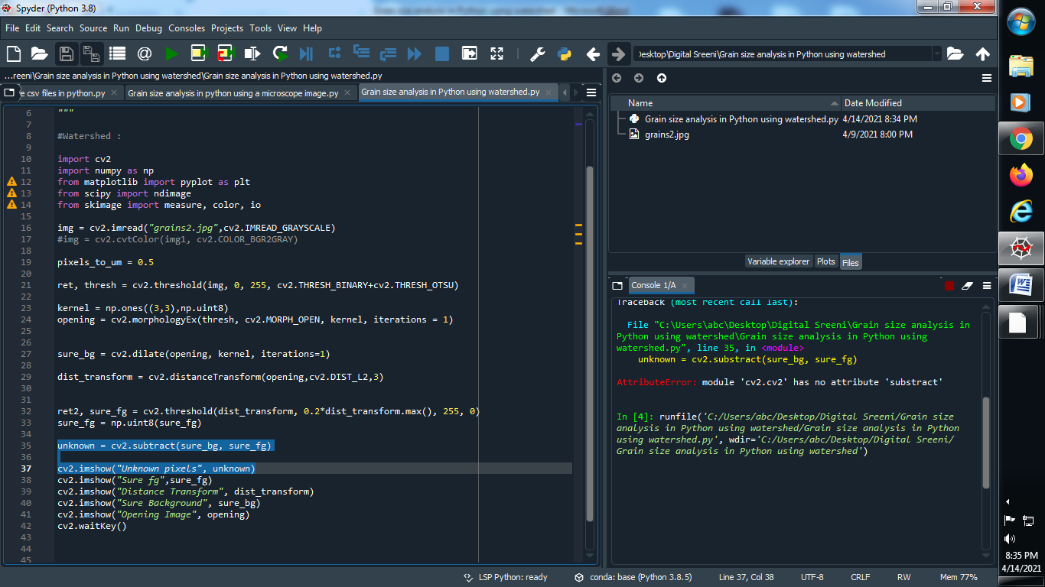

**Output :**

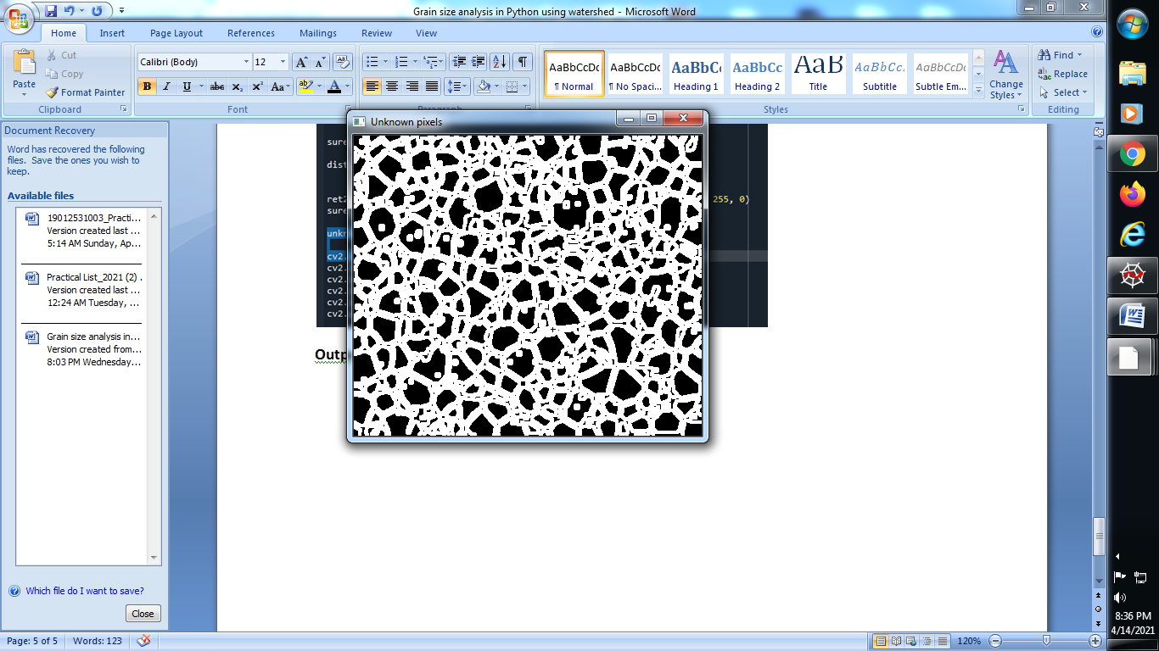

**Use of markers in image :**

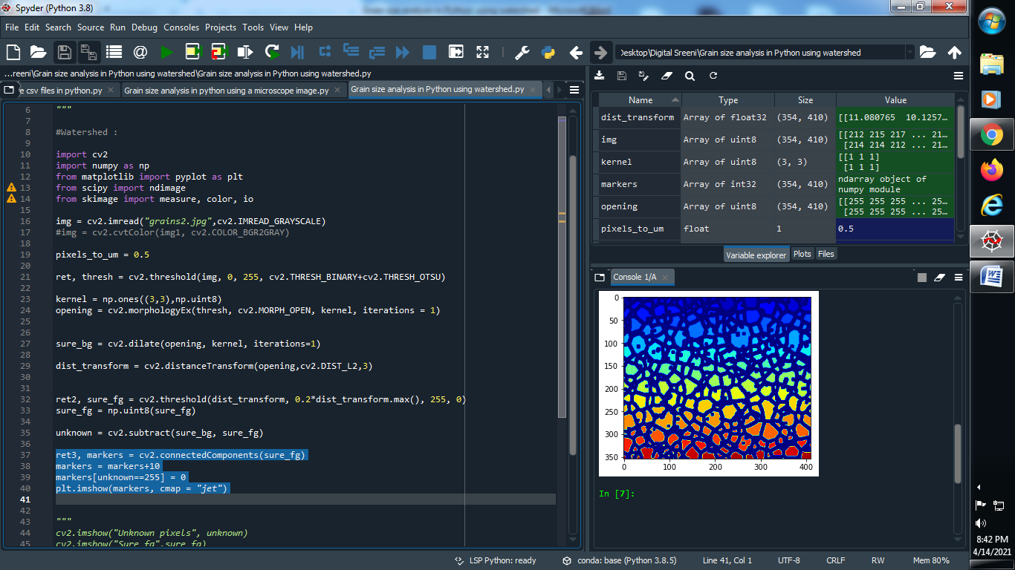

**Output :**

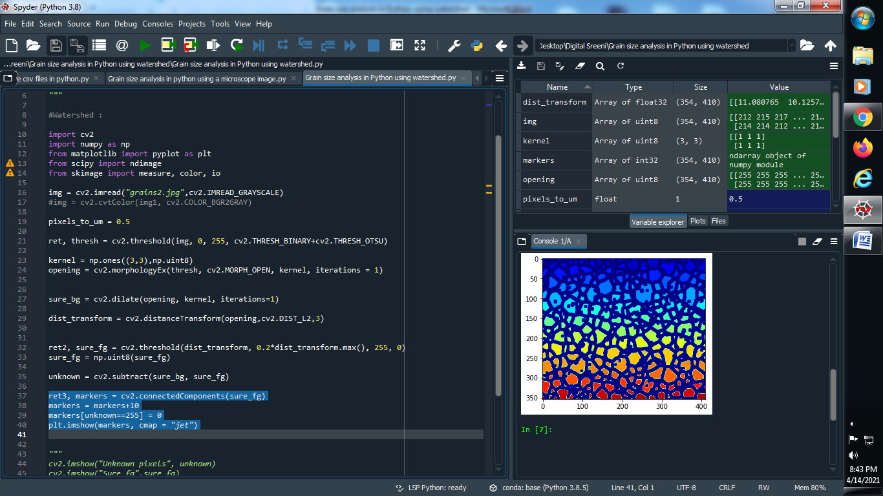

**Use Watershed in image :**

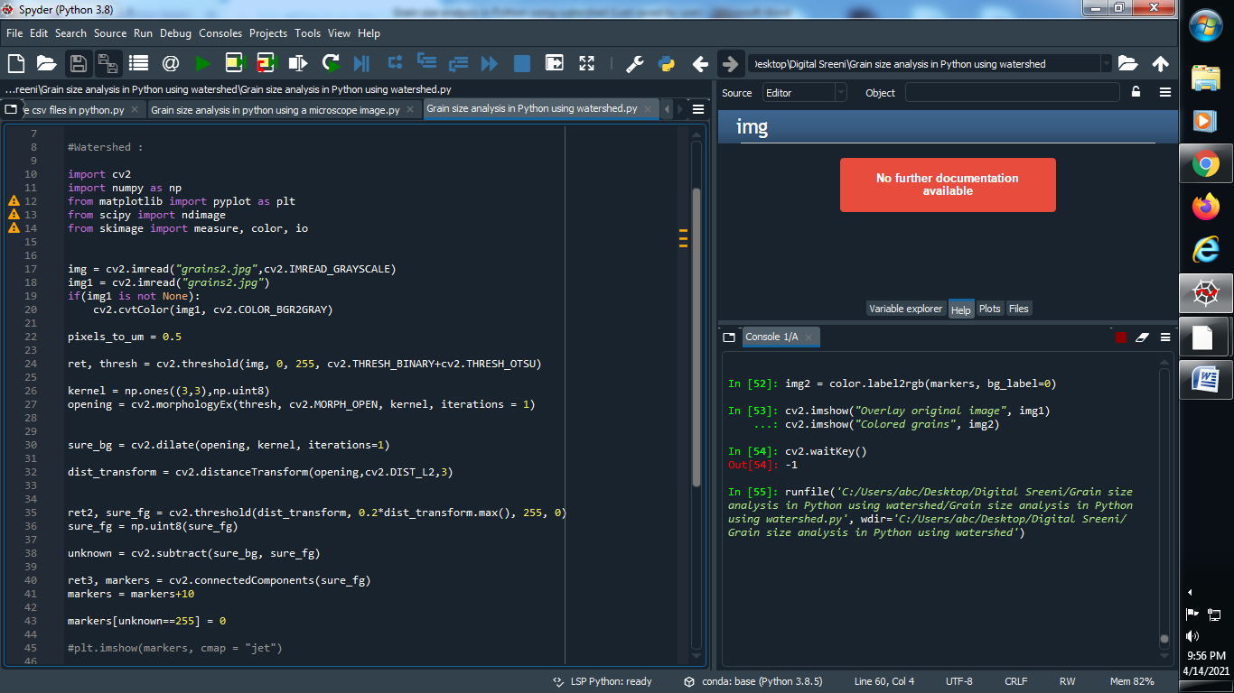

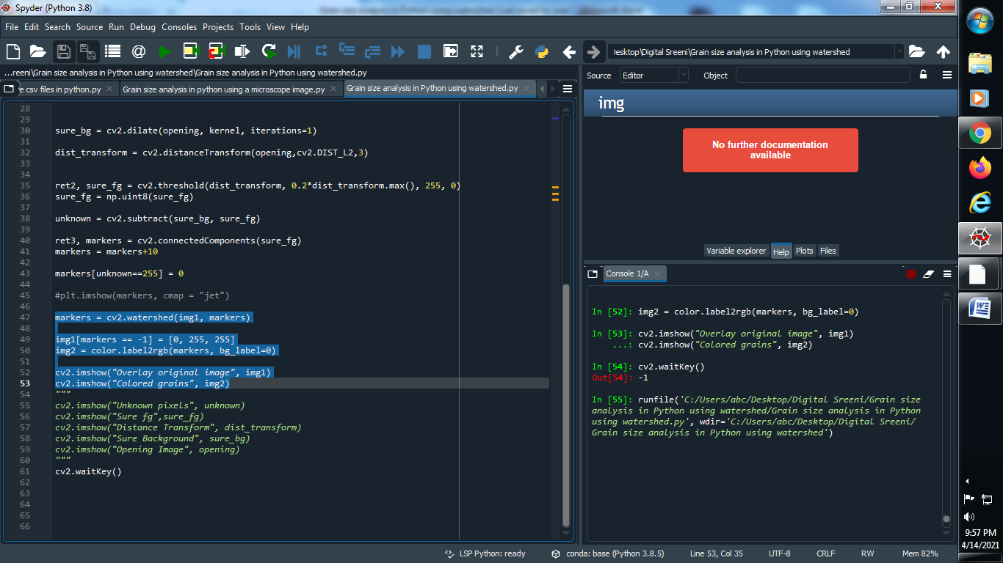

**Output :**

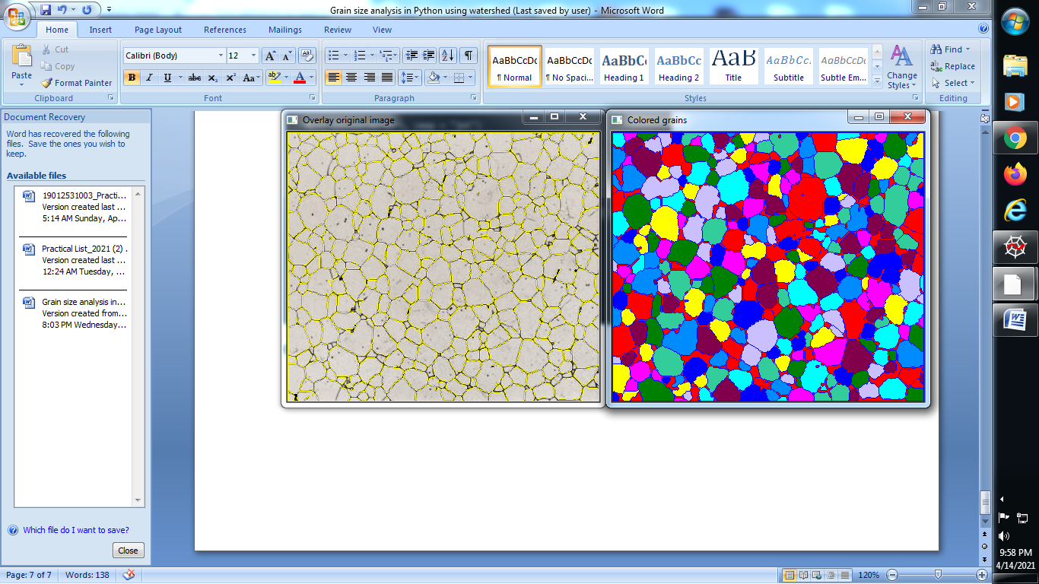

**Remove the border in above the image using clear border library :**

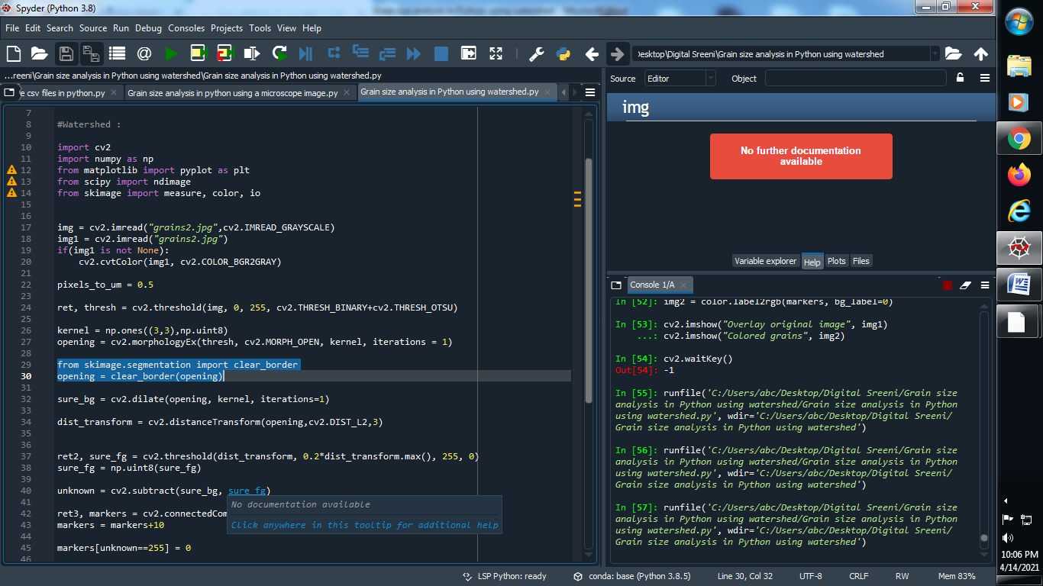

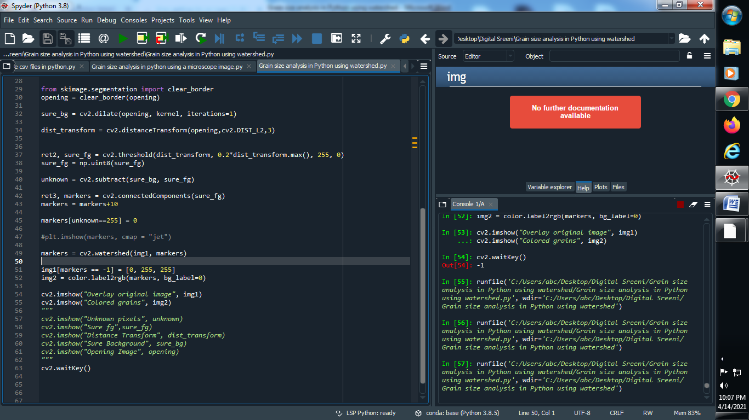

**Output :**

